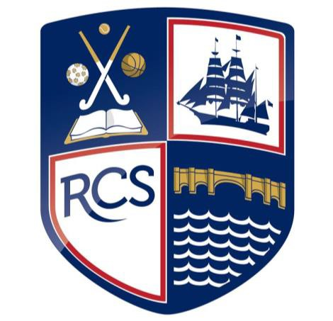
Assessment Process

1
Policy

We believe that our new system of assessment has been constructed to give every student, regardless of context or background, the best opportunity to excel at learning at Redbridge Community School. Our model has been designed around the ‘knowledge curriculum’ and ‘cultural deficit’ by ED Hirsch.

Person responsible - | Stuart Ramsey (Assistant Headteacher)
Last review date - | January 2023
Next review date - | Ongoing evaluation

Contents
- Aims | Page 3
- Legislation and Guidance | Page 3
- Rationale | Page 3
- Monitoring | Page 4
- Assessment Approaches | Page 4
- Inclusion | Page 5
- Training | Page 5
- Roles and responsibilities | Page 5
- Assessment Cycle | Page 6
- Reporting to Parents | Page 6

- Aims

This policy aims to:

- Provide clear guidelines on our approach to formative and summative assessment
- Establish a consistent and coherent approach to recording summative assessment outcomes and reporting to parents
- Clearly set out how and when assessment practice will be monitored and evaluated

- Legislation and guidance

Since the removal of National Curriculum levels in 2014, schools have been free to develop their own approaches to assessment.

- This policy refers to the recommendations in the Final Report of the Commission on Assessment without Levels.
- It also refers to statutory reporting requirements set out in the Education (Pupil Information) (England) Regulations 2005: schedule 1.

- Rationale

We believe that the use of national curriculum levels has held back many of our students by labelling them in a way that does not support their dream and aspirations. It has in the past promoted low expectations, which is incongruent to our school’s values and beliefs. Given our context, and starting point, we believe that our school curriculum and assessment regime will tackle a cultural deficit that inhibits our students, many of whom receive the pupil premium. This is supported by a sophisticated tracking process and our easy to understand reporting system accessed and understood by our parents through consultation. We believe this makes it easier for our parental community to hold us to account and ensure that our students are equipped for the tougher rigors of the school GCSE standard. We believe our school curriculum and assessment regime addresses ‘knowledge deficit’, in that it combines key knowledge within each subject alongside the relevant knowledge application.

- Being systematically sequenced to ensure that declarative and procedural knowledge build upon what has been taught before
- Having clear and purposeful assessment practices to check understanding at key points and identify and correct misconceptions
- Considering carefully our local contexts, assessment is adapted to address any gap or delay in learning (especially considering the pandemic)
- Providing development to support where student backgrounds may have gaps in knowledge

We believe that our assessment procedures:

- Create further, an achievement culture for the benefit and promotion of academic excellence regardless of context and starting points.
- Allow meaningful tracking of pupils towards end of year expectations including regular and accountable feedback to parents.
- Feedback from school assessments contribute to improved teaching and learning, which links to tangible lesson key questions for investigation.
- Will be reliable, fair and free from bias by removing labels that inhibit learning.
- Promote school measures, generate individual student information against expected standards and progress over time.
- Provides information about student capabilities and identifies who is exceeding, meeting or falling below expected standards.
- Develop a system that transfers relevant knowledge and skills across subjects that form a curriculum continuum between KS3 and KS4.

- Monitoring

In line with the Department for Education Teachers’ Standards, ‘teachers must give pupils regular feedback, both orally and through accurate marking’. Therefore, colleagues should expect to have their students’ books/work/assessments checked during learning walks, peer to peer critiques, observations and as part of a work‐scrutiny by the Head of Faculty or the Senior Leadership Team. In addition, we appoint external assessment experts to audit our assessment approaches.

- Assessment Approaches

At Redbridge Community School we see assessment as an integral part of teaching and learning, and it is inextricably linked to our curriculum. We use two broad overarching forms of assessment: day-to-day in-school formative assessment, (in-school and nationally) summative assessment.

5.1 Formative assessment

Effective formative assessment enables:

- Teachers to identify how pupils are performing on a continuing basis and to use this information to provide appropriate support or extension, evaluate teaching and plan future lessons
- Pupils to measure their knowledge and understanding against learning objectives, and identify areas in which they need to improve
- Parents to gain a broad picture of where their child’s strengths and weaknesses lie, and what they need to do to improve

Formative Assessment involves the ongoing monitoring of student progress that shapes future lesson planning and intervention. This includes low stakes testing where a simple test is employed to ascertain the extent to which knowledge is being retained and to establish an understanding of gaps in knowledge and/or skills at individual and whole class level. This is not necessarily graded with the focus instead on positive actionable feedback to help address misconceptions or adjust teaching and learning, informing next steps. Therefore, it is acceptable for teachers to move away from schemes of work where it is clear students’ learning in a particular area needs to be reinforced or re-visited. Examples include, but are not limited to;

- verbal feedback
- low stakes questioning/testing,
- self and peer-assessment
- observations
- practical assessment.

5.2 Summative assessment

Effective summative assessment enables:

- School leaders to monitor the performance of pupil cohorts, identify where interventions may be required, and work with teachers to ensure pupils are supported to achieve sufficient progress and attainment
- Teachers to evaluate learning at the end of a unit or period and the impact of their own teaching
- Pupils to understand how well they have learned and understood a topic or course of work taught over a period of time. It should be used to provide feedback on how they can improve
- Parents to stay informed about the achievement, progress and wider outcomes of their child across a period

Summative Assessment involves designated graded assessment and is a means to measure learning at a given point in time. A robust approach towards summative assessment is essential to inform valid school reports, reliable whole school analysis and enrichment groupings across cohorts. Examples include, but are not limited to:

- External examination papers (e.g. GCSEs)
- Baseline Testing (e.g. MIDYIS)
- Interim assessments
- End-of-unit tests
- End-of-term assessments

6. Inclusion

The principles of this assessment policy apply to all pupils, including those with special educational needs or disabilities. Assessment will be used diagnostically to contribute to the early and accurate identification of pupils’ special educational needs and any requirements for support and intervention.
We will use meaningful ways of measuring all aspects of progress, including communication, social skills, physical development, resilience and independence. We will have the same high expectations of all pupils. However, this should account for the amount of effort the pupil puts in as well as the outcomes achieved. For pupils working below the national expected level of attainment, our assessment arrangements will consider progress relative to pupil starting points, and take this into account alongside the nature of pupils’ learning difficulties.

7. Training

The CPD program includes keeping staff up to date with developments in assessment practice through internal sessions including, ‘Data Snippets’, Twilight Sessions, Teaching & Learning briefings, Middle Leader Meetings, Challenge Meetings. Activities include but are not limited to moderation of assessment both within school and across local schools, sharing of best practice through Peer to Peer as well as Examination Board moderation resources and external assessment expert meetings.

8. Roles and Responsibilities

Governors are responsible for:

- Being familiar with statutory assessment systems as well as how the school’s own system of non-statutory assessment captures the attainment and progress of all pupils
- Holding school leaders to account for improving pupil and staff performance by rigorously analysing assessment data

The Headteacher is responsible for:

- Ensuring that the policy is adhered to
- Monitoring standards in core and foundation subjects
- Analysing pupil progress and attainment, including individual pupils and specific groups
- Prioritising key actions to address underachievement
- Reporting to governors on all key aspects of pupil progress and attainment, including current standards and trends over previous years

Teachers are responsible for:

- Following the assessment procedures outlined in this policy
- Being familiar with the standards for the subjects they teach
- Keeping up to date with developments in assessment practice

9. Assessment Cycle

The assessment model is similar in both Key Stages. At Key Stage 3 we monitor progress at three points in the year – at the end of each term. At Key Stage 4 we monitor progress at three points in the year, within each term.

Key Stage 3/4

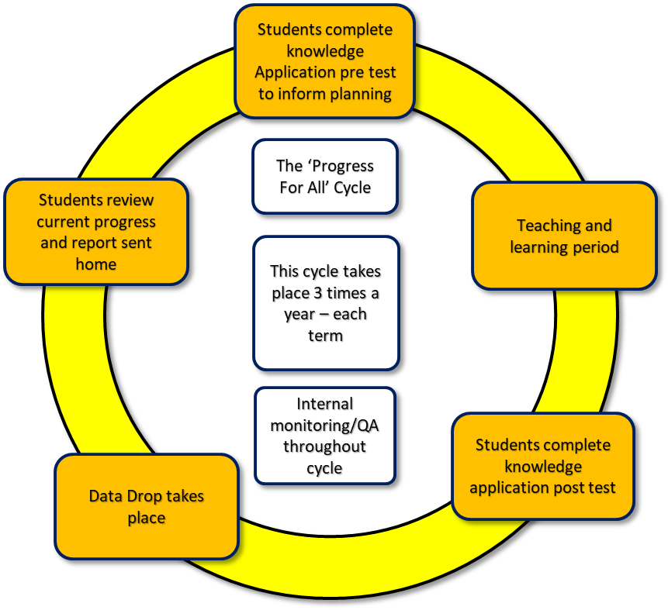
10. Reporting to Parents

As part of Redbridge Community School’s commitment to reducing teachers’ workload, written reports have been replaced with Progress Trackers and Parents’ Evenings. Parents are consulted about reporting and its format and accessibility. For all cohorts we report to parents once per term.

